**ASSIGNMENT - 2**

**Q.1.)** Git Setup.

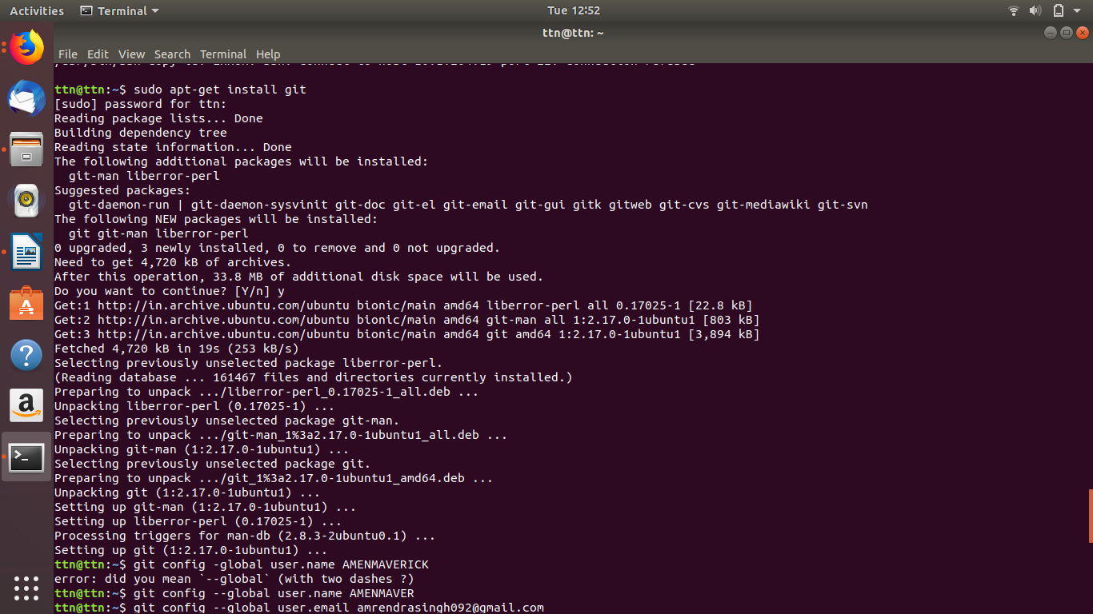

**Q.2.)** Initialize a Git Repository



**Q.3.)** Add files to the repository.

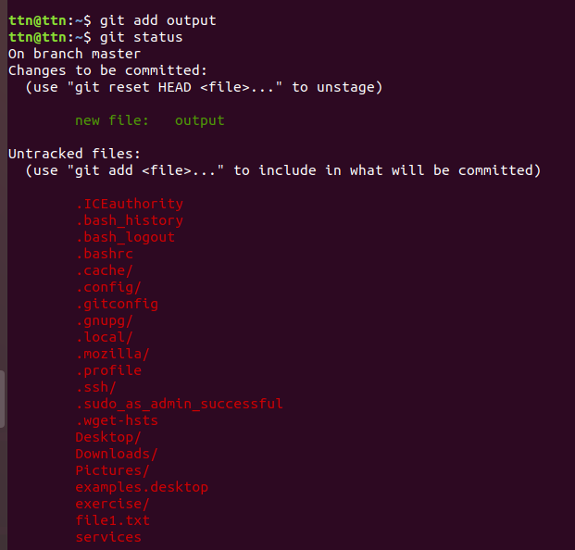

**Q.4.)** Unstage 1 file

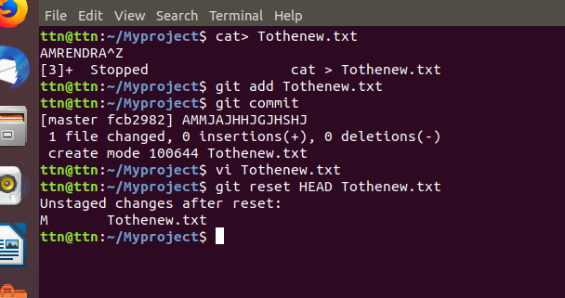

**Q.5.) Commit the file.**

**Solution :**

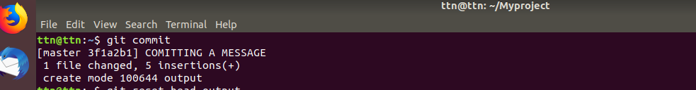

**Q.6.) Add a remote.**

**Solution :**

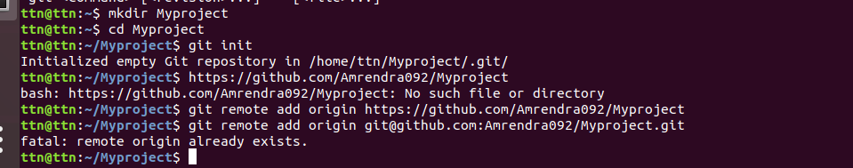

**Q.7.) Undo changes to a particular file.**

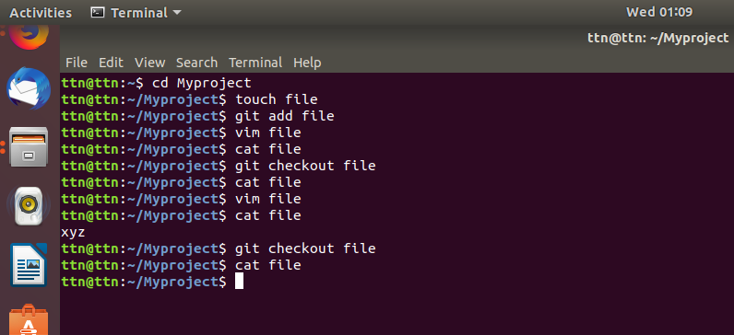

**Q.8.) Push changes to Github.**

**Solution :**

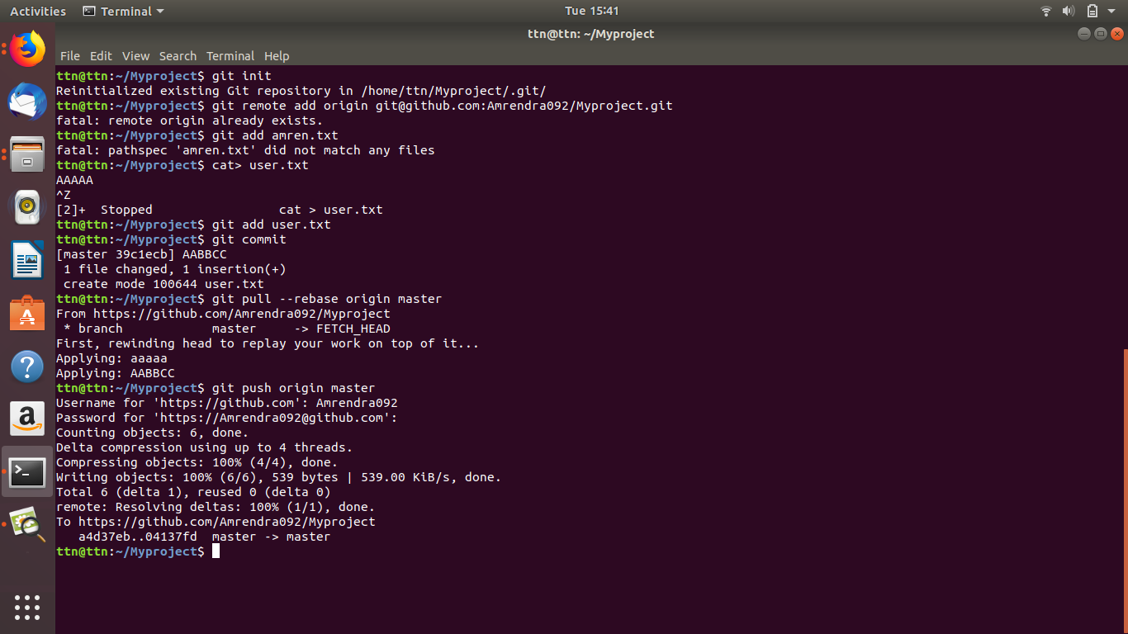

**Q.9.) Clone the repository.**

**Solution :** 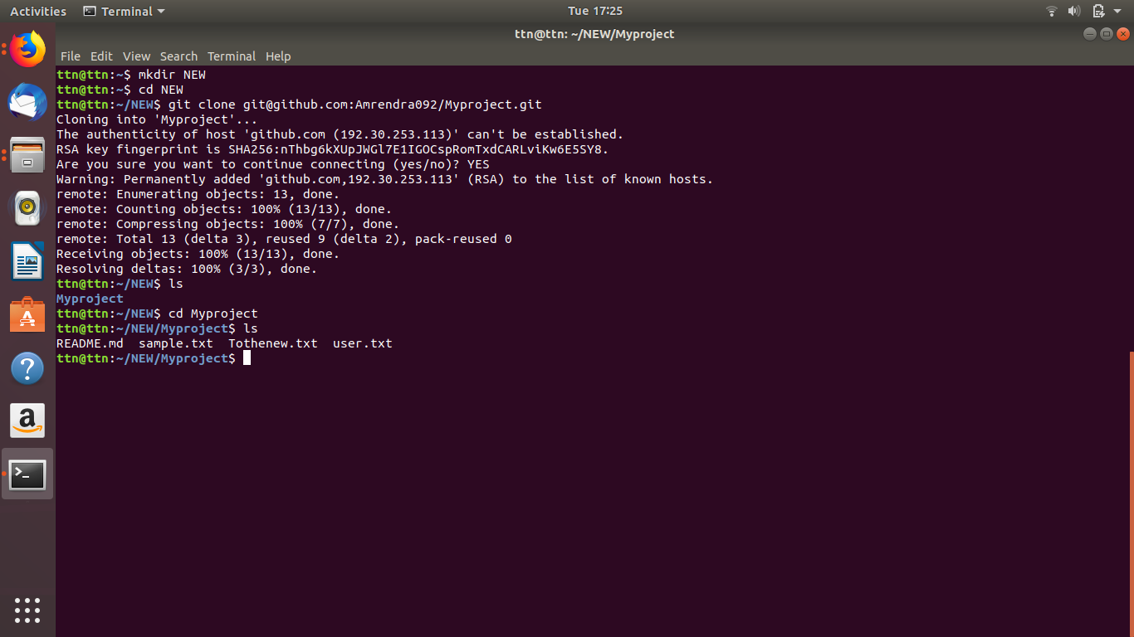

**Q.10.) Add changes to one of the copies and pull the changes in the other.**

**Solution :**

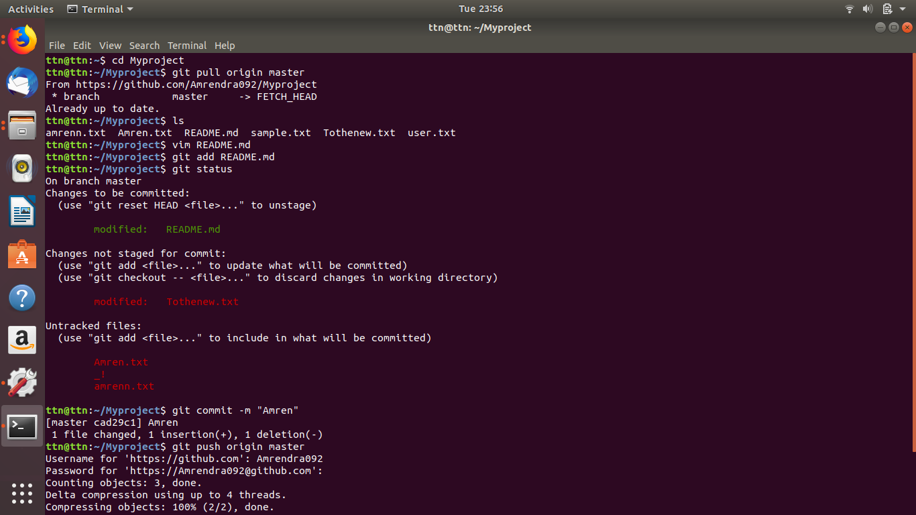

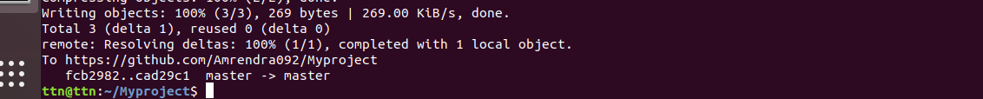

**Q.11.) Check differences between a file and its staged version.**

**Solution :**

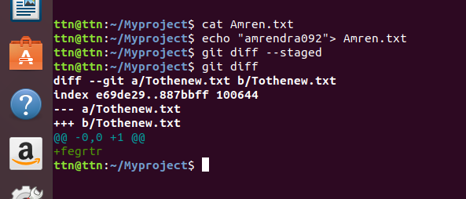

**Q. 12 ) Ignore a few files to be checked in.**

**Solution :**

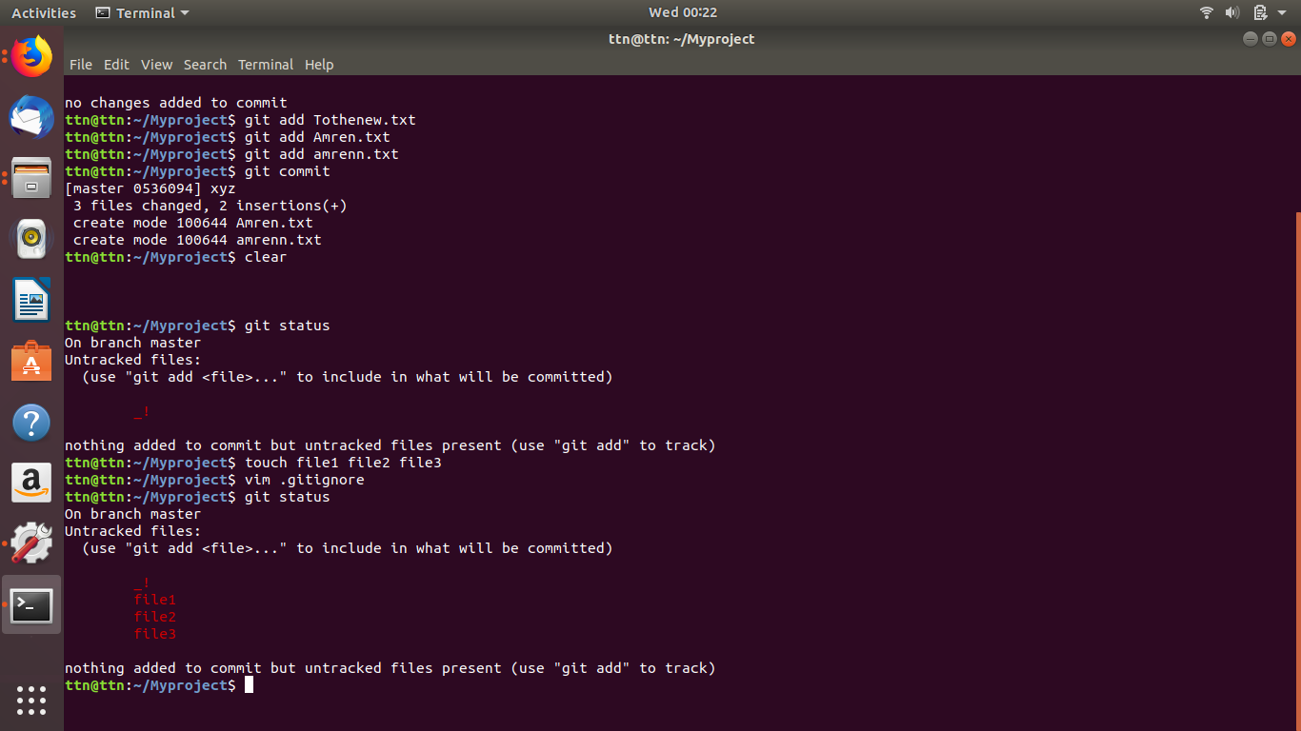

**Q.13 ) Create a new branch.**

**Solution :** 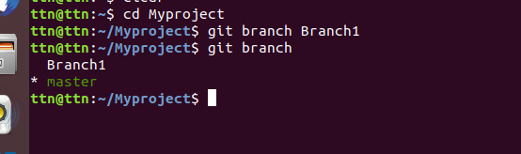

**Q.14. ) Diverge them with commits.**

**Solution :**

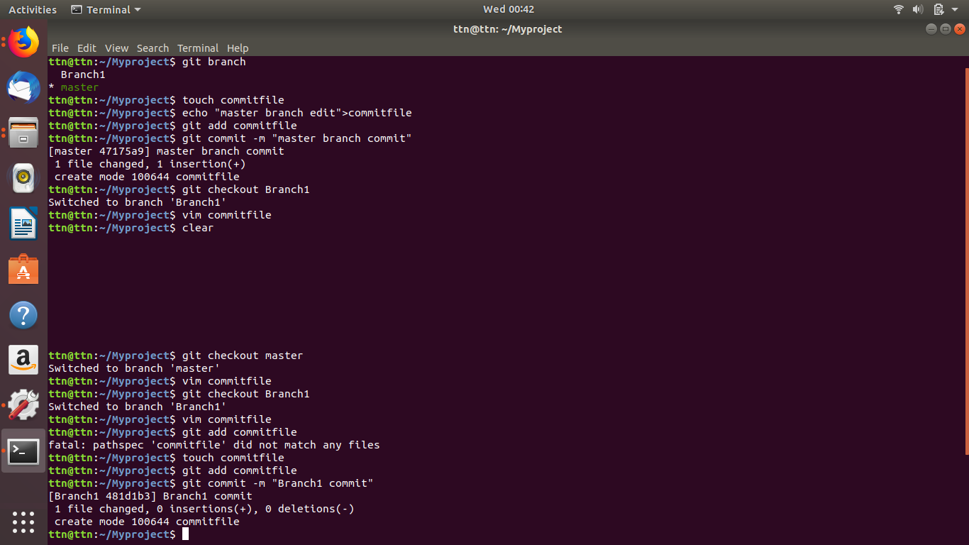

**Q. 15.) Edit the same file at the same line on both branches and commit.**

**Solution :**

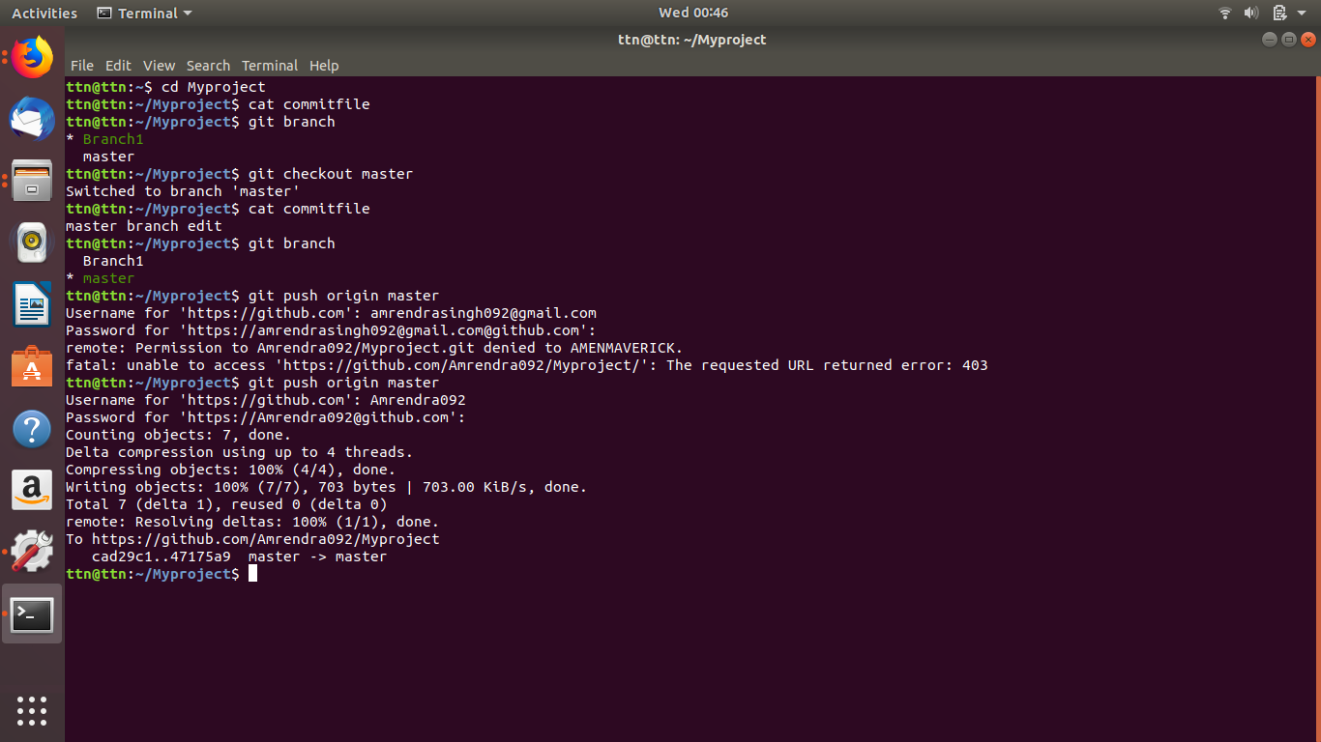

**Q.17 ) Stash the changes and pop them.**

**Solution :**

